March 22, 2020

Dear YMA Families,

In the light of the COVID19 and school closures, Mrs. Faour and I put in place a distance E-learning plan to continue instruction during this period of time. Your child will receive instruction on a weekly basis (mini-work plan) to continue practicing skills and concepts covered so far. We will be using resources offered by our district through the Clever portal. On a weekly basis your child will be required to login to our class pages on our school website: <https://www.yonkerspublicschools.org/YMA> to access the schedule for them to follow. Be sure to check Mrs. Faour’s page for math and my page for ELA. Students will find their work plan schedule under “My Assignments”.

When going onto Clever for ELA, students will be using the following apps to complete their weekly plans.

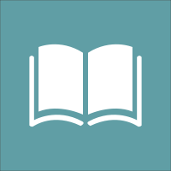 Commonlit App: Reading Comprehension

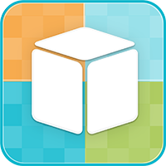 iReady App: Vocabulary Acquisition/Comprehension

\*When students are asked to respond to a “Discussion Question” on their work plan, they will click on “Discussion” on my class page.